**Assignment 1 Report**

#### course: COMP9444

#### term: 2020T2 full name: Zhaokun Su

#### zID: z5235878

### Part 1: Japanese Character Recognition

1.Model Netlin:

Required: Netlin model computes a linear function and of pixels in the image, followed by log softmax;

After 10 Epoch: the result figure shows below:

Final accuracy: 70%

Confusion matrix are shown below:

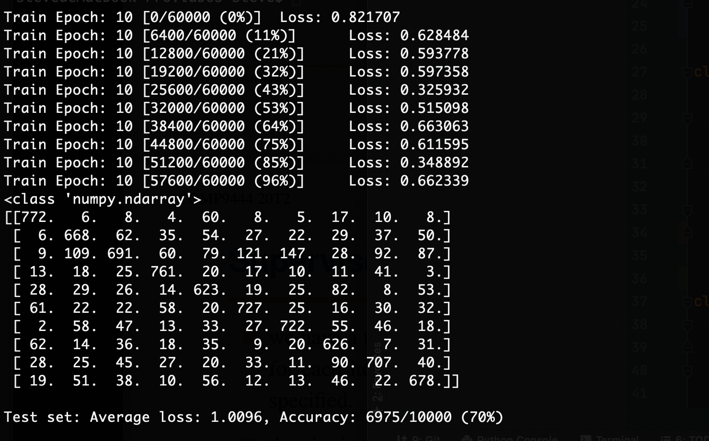

2.Model Netfull:

Required: Implement a fully connected 2-layer network Netfull, using tanh at the hidden nodes and log softmax at the output node;

Choosing different values for the number of hidden nodes:

When we choose 30 nodes in the hidden layer:

After 10 Epoch: the result figure shows below:

Final accuracy: 78%

Confusion matrix are shown below:

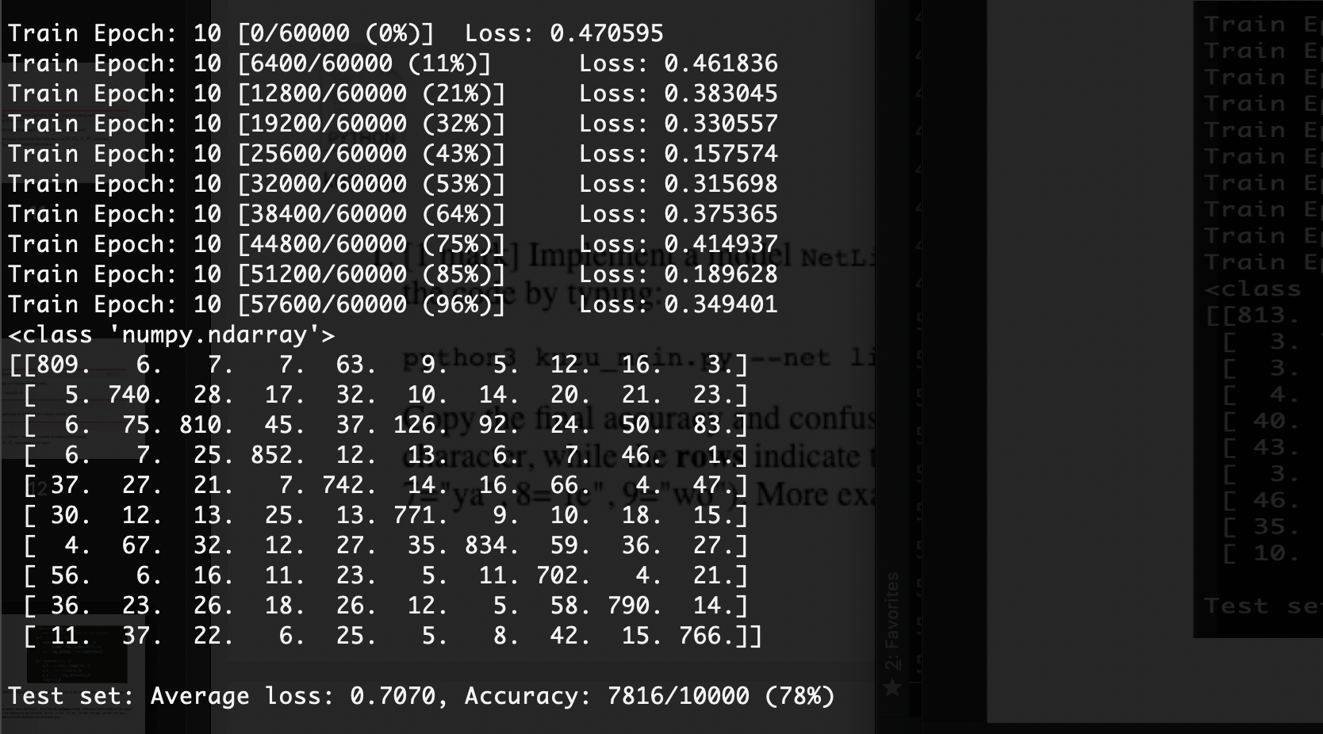

When we choose 50 nodes in the hidden layer:

After 10 Epoch: the result figure shows below:

Final accuracy: 81%

Confusion matrix are shown below:

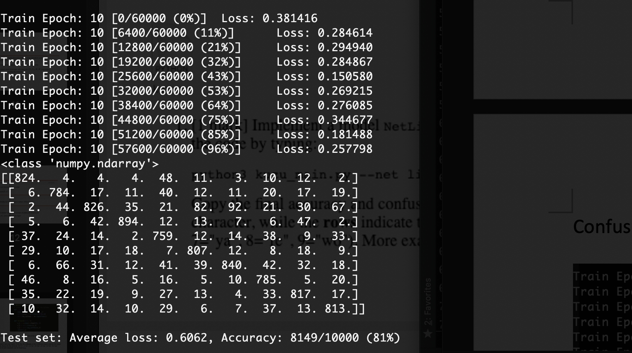

When we choose 70 nodes in the hidden layer:

After 10 Epoch: the result figure shows below:

Final accuracy: 83%

Confusion matrix are shown below:

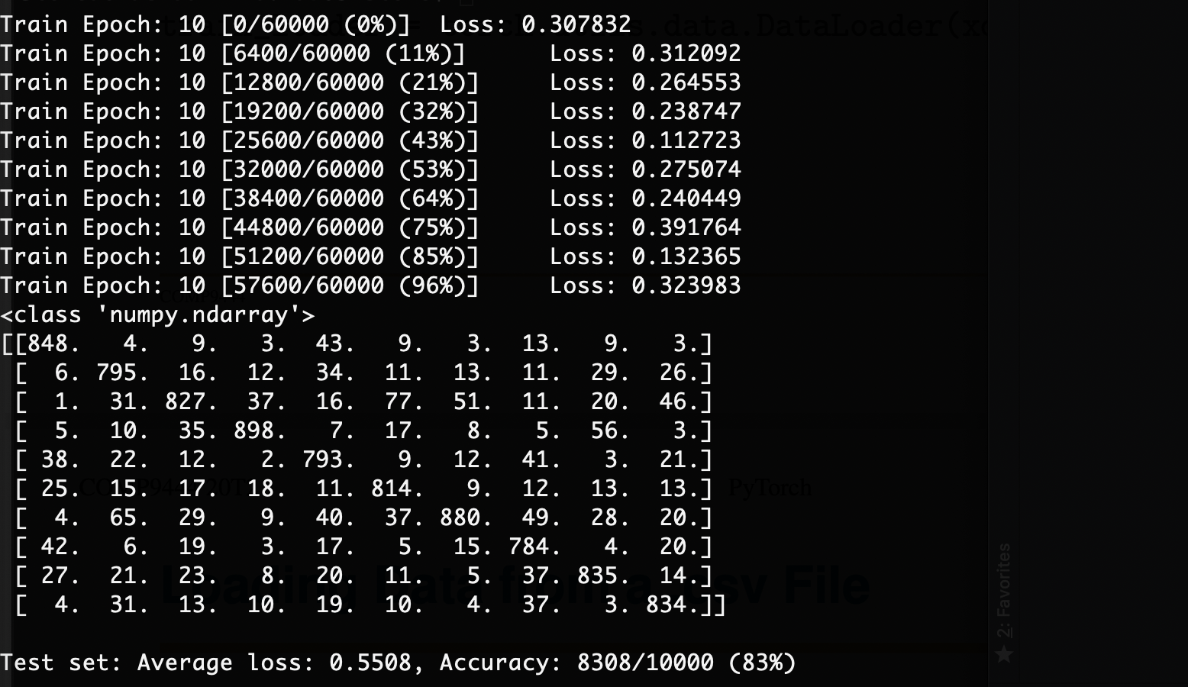

When we choose more than 70 nodes in the hidden layer, we could find that there is little change in final accuracy, so we choose 70 as our best number of hidden nodes.

3.Model NetConv:

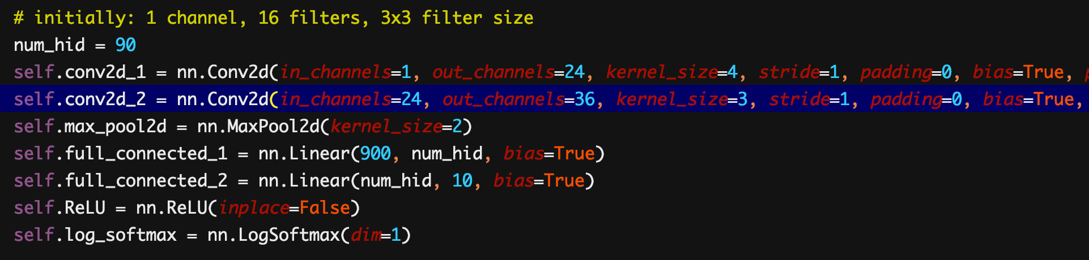

When we create our convolutional, we use two different combinations of parameters:

In the first convolutional layer: we use 24 filters and kernel_size 4 for each filter;

In the second convolutional layer: we use 36 filters and kernel_size 3 for each filter;

And we add max pooling approach every time after convolutions with max pooling size 2.

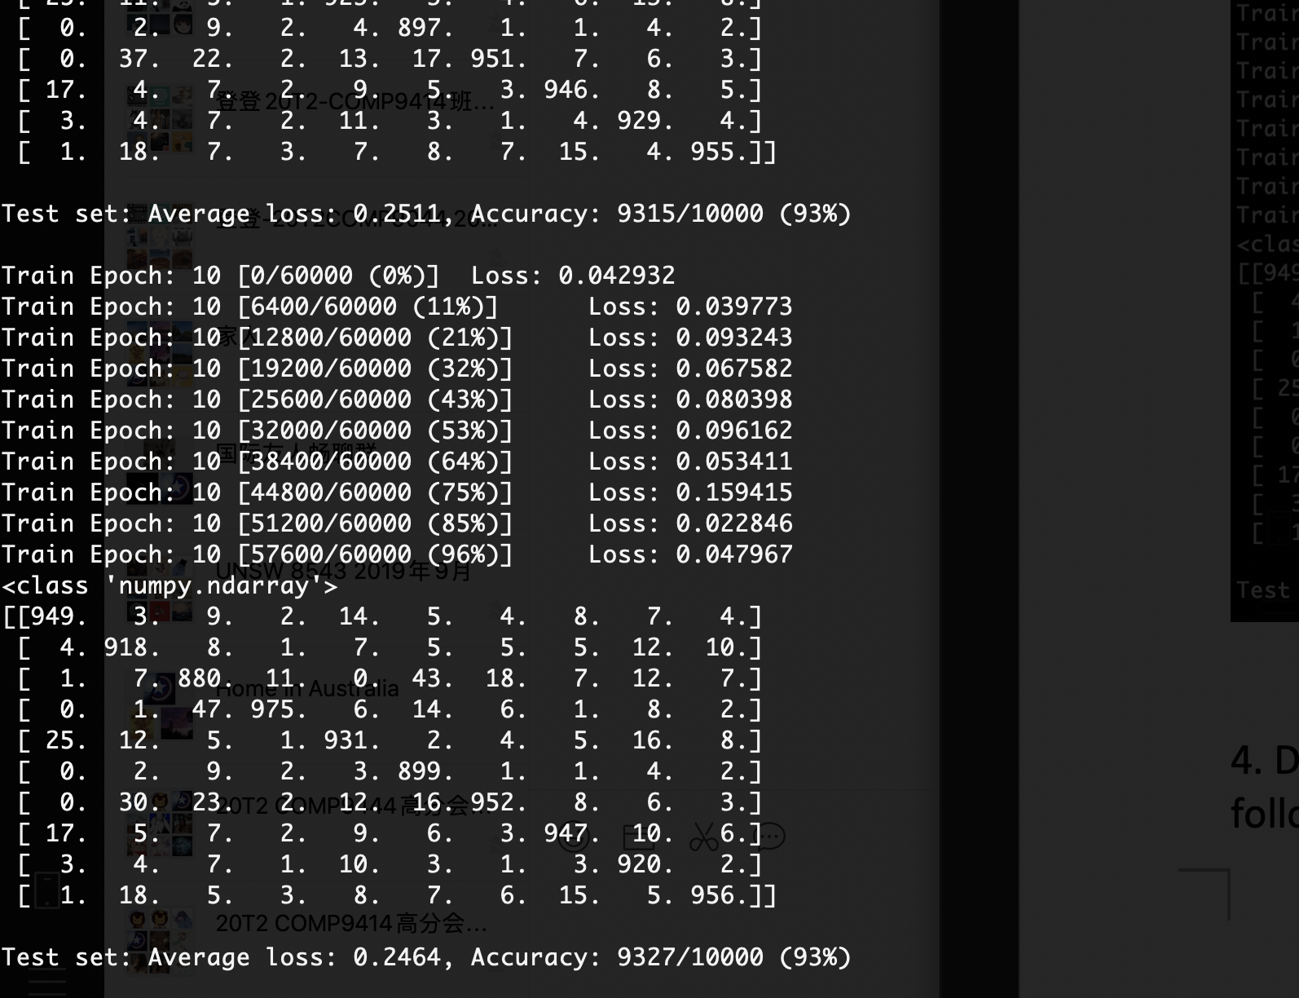

We can see that after epoch 8, the accuracy of our model had reached to 93% successfully.

4. Discuss what you have learned from this exercise, including the following points:

a. the relative accuracy of the three models,

when Netlin < Netfull < NetConv we look at these 3 different models: Netlin, Netfull and NetConv.

Model complexity: Netlin < Netfull < NetConv;

The highest accuracy: Netlin (70%) < Netfull (83%) < NetConv ()

The complexity of networks we established is increasing.

Normally, the more complexity the model has, the higher accuracy it gets.

b. the confusion matrix for each model: which characters are most likely to be mistaken for which other characters, and why?

Maybe it is easier to make a mistake classification when some character is similar with some or other characters.

c. you may wish to experiment with other architectures and/or metaparameters for this dataset, and report on your results; the aim of this exercise is not only to achieve high accuracy but also to understand the effect of different choices on the final accuracy.

### Part 2: Twin Spirals Task

1. code is seen in file spiral.py

2. we run command in terminal:



In 2800 epoch, we get 100% accuracy.

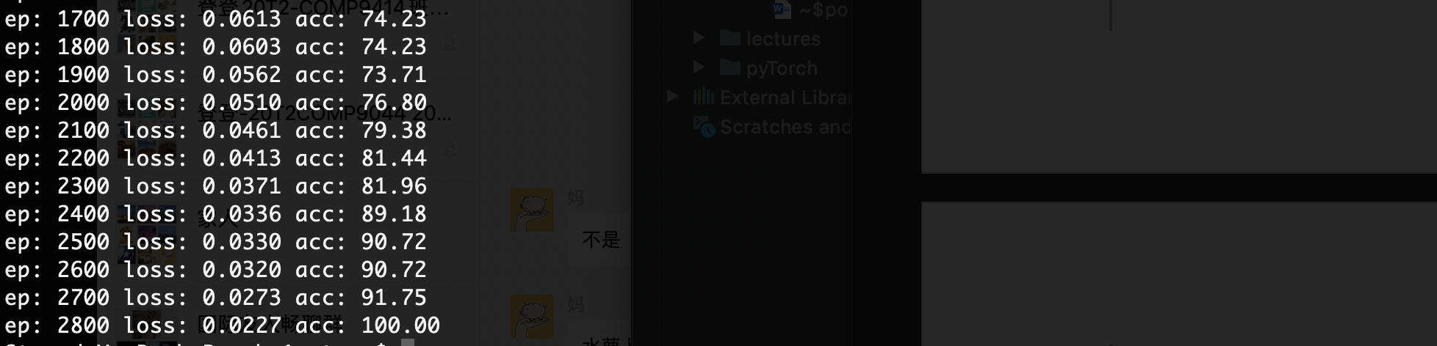

And we get our output png figure:



The result is shown below: polar_out.png

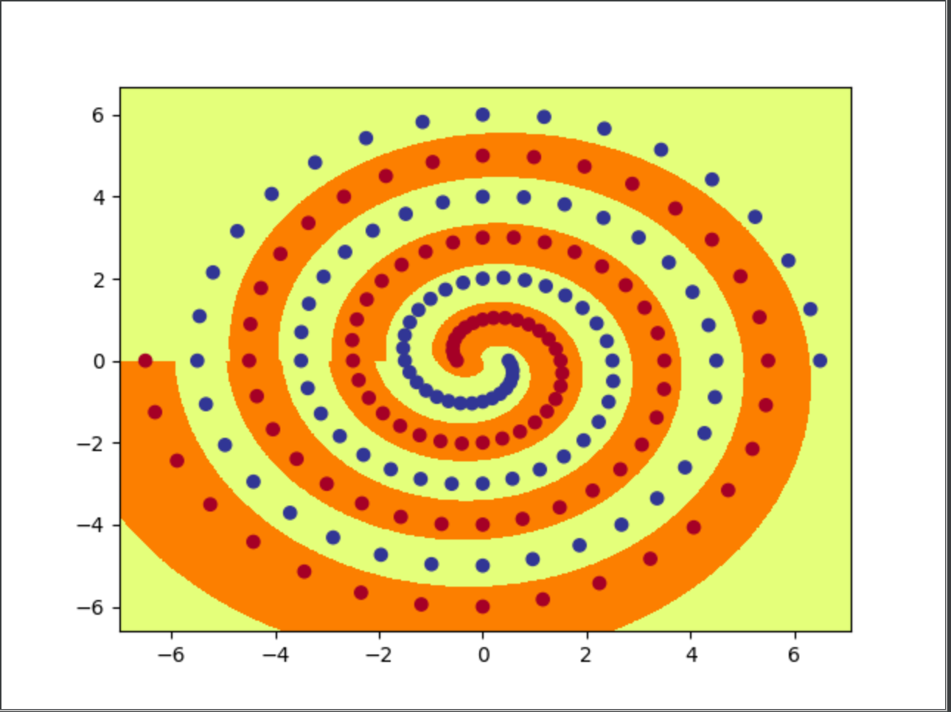

2. when we try num_hid to be 9, 8, 7 and 6 using command:

python3 spiral_main.py --net polar --hid “num_hid” –epochs 20000









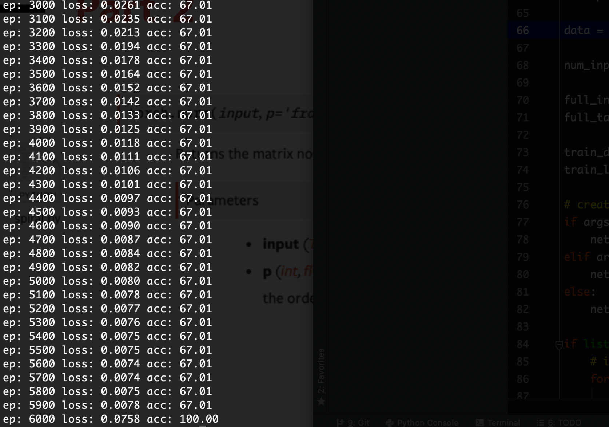

The figure below is figure generated when hid_num = 6

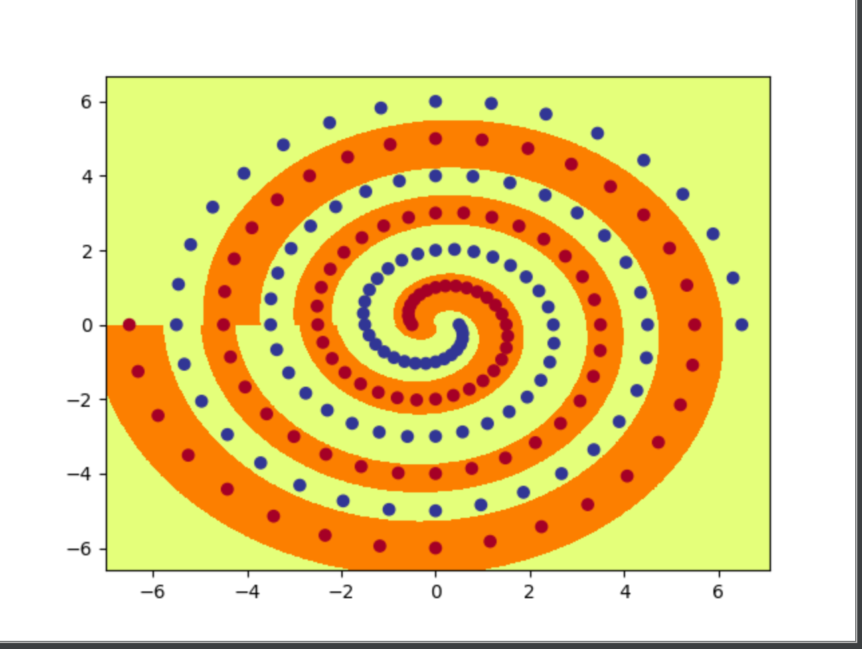

They all reach to 100% accuracy in the end.

When we try numbers less than 6 for several times, the accuracy cannot reach to 100% within 20000 epochs, e.g. running --hid = 5, we get below results.

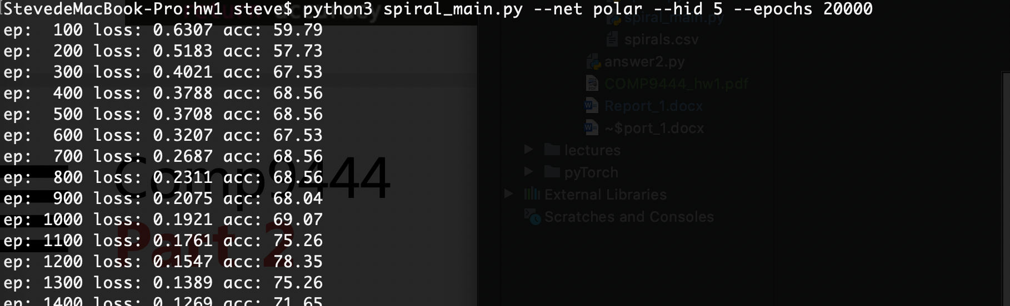

…..

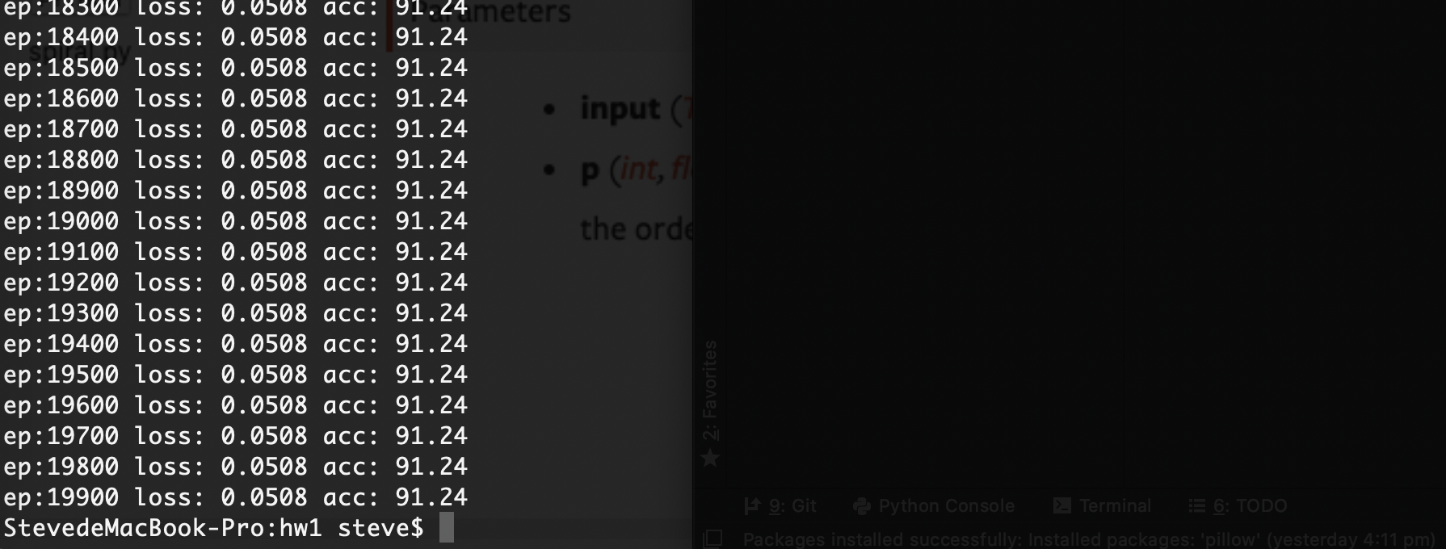

We try a lot of times running, all of them failed. And failure as well when we try --hid < 5 and the performance is even worse.

As a result, the minimum number we have found is 6.

3. code is seen in file spiral.py

4. Initially, we run initial command:

First, we can see all parameter default values:

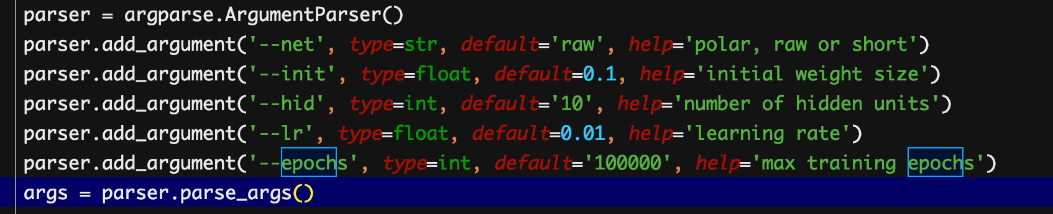

Then, we run command below:

For this particular choice:

We get --init value is: 0.1 and --hid value is: 10;

We could see in this time, accuracy failed to increase to 100% within 20000 epochs (just to around 50% in 20000 epochs);

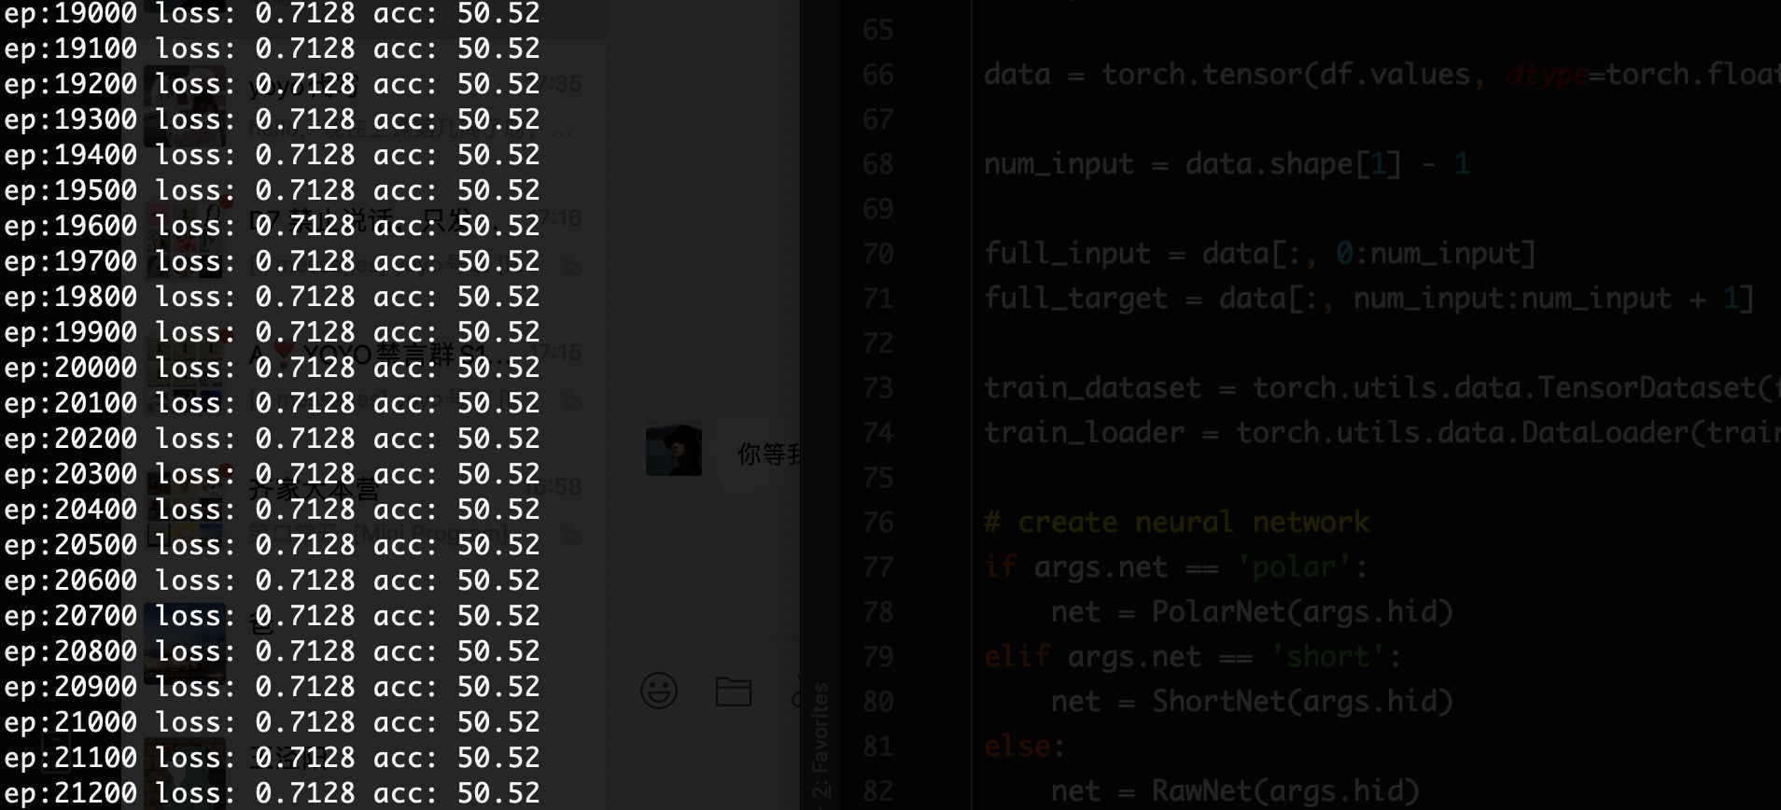

Now, we try to change –init parameter in order to get a better performance.

Firstly, we try to decrease our –init value by running such command:



We get parameters:

--init: 0.05

--epochs: 20000

--hid_num: 10 (default)

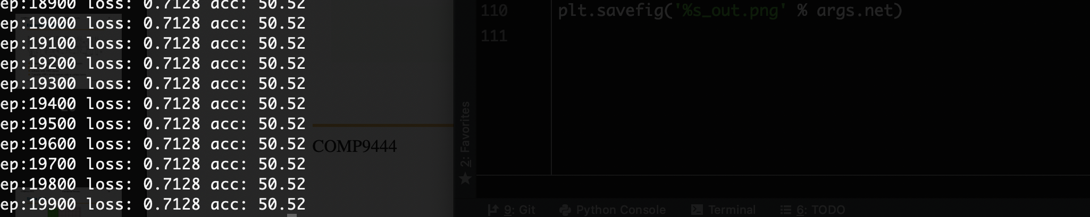

The performance is not good within 20000 epochs.

After this trial, we tried to some other group of smaller values of --init:

They all get bad results.

--init: 0.03

--epochs: 20000

--hid_num: 10 (default)

Final accuracy in 20000-th epoch: 53.27

--init: 0.05

--epochs: 20000

--hid_num: 10 (default)

Final accuracy in 20000-th epoch: 50.52

--init: 0.08

--epochs: 20000

--hid_num: 10 (default)

Final accuracy in 20000-th epoch: 51.68

So in the next following steps: we tried to increase –init values greater than 0.1:

--init: 0.15

--epochs: 20000

--hid_num: 10 (default)

Result shown below:

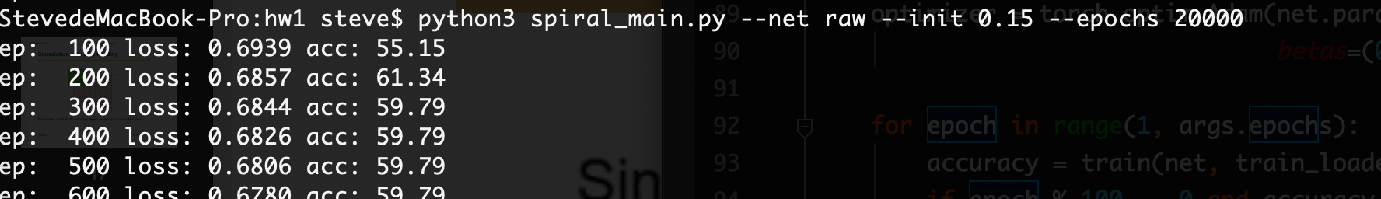

……

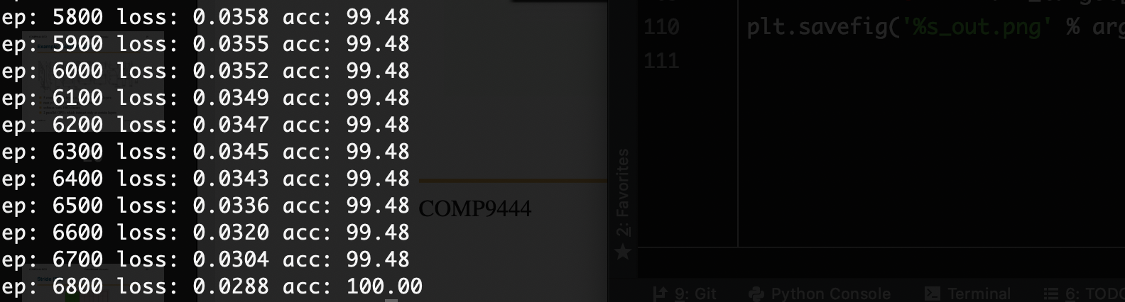

In epoch 6800, it reached to 100% acc.

Picture generated:

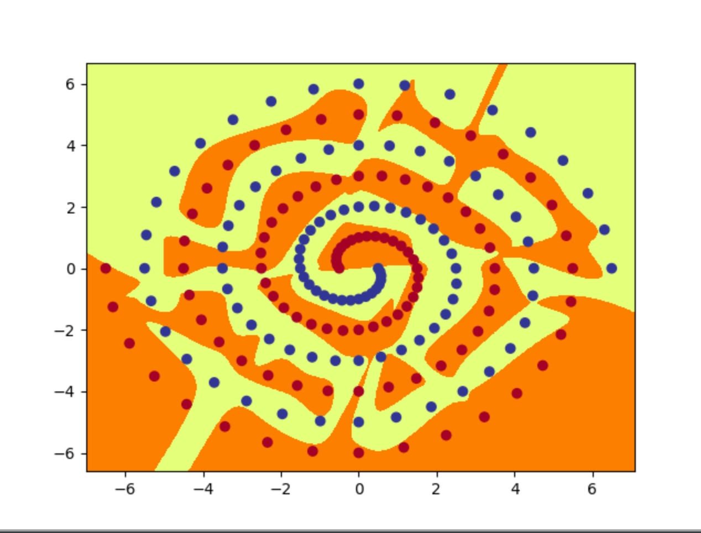

--init: 0.2

--epochs: 20000

--hid_num: 10 (default)

Final accuracy in 20000-th epoch: 53.27

Result shown below:

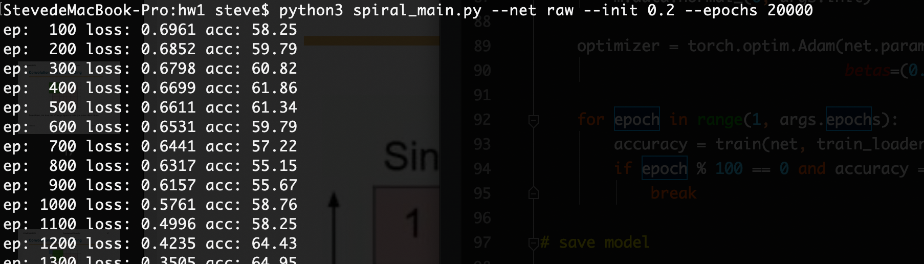

……

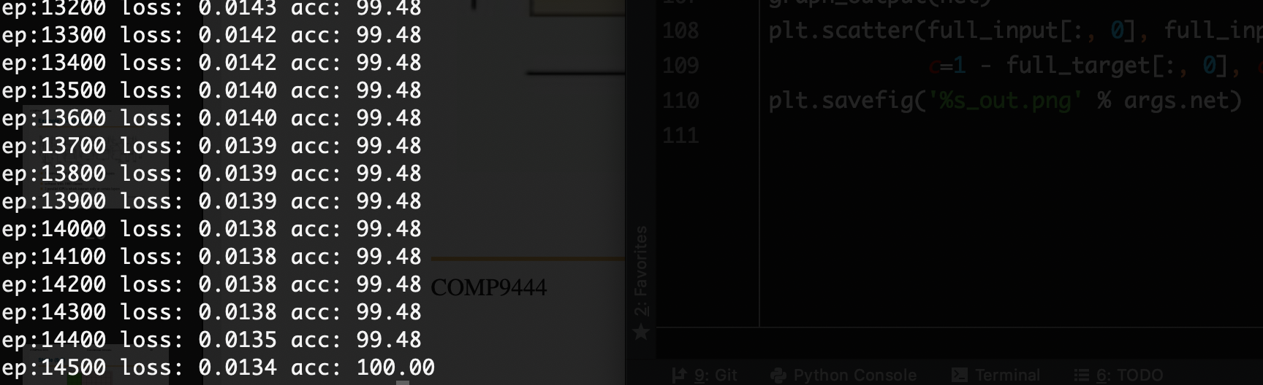

In epoch14500, it reached to 100% acc.

Picture generated:

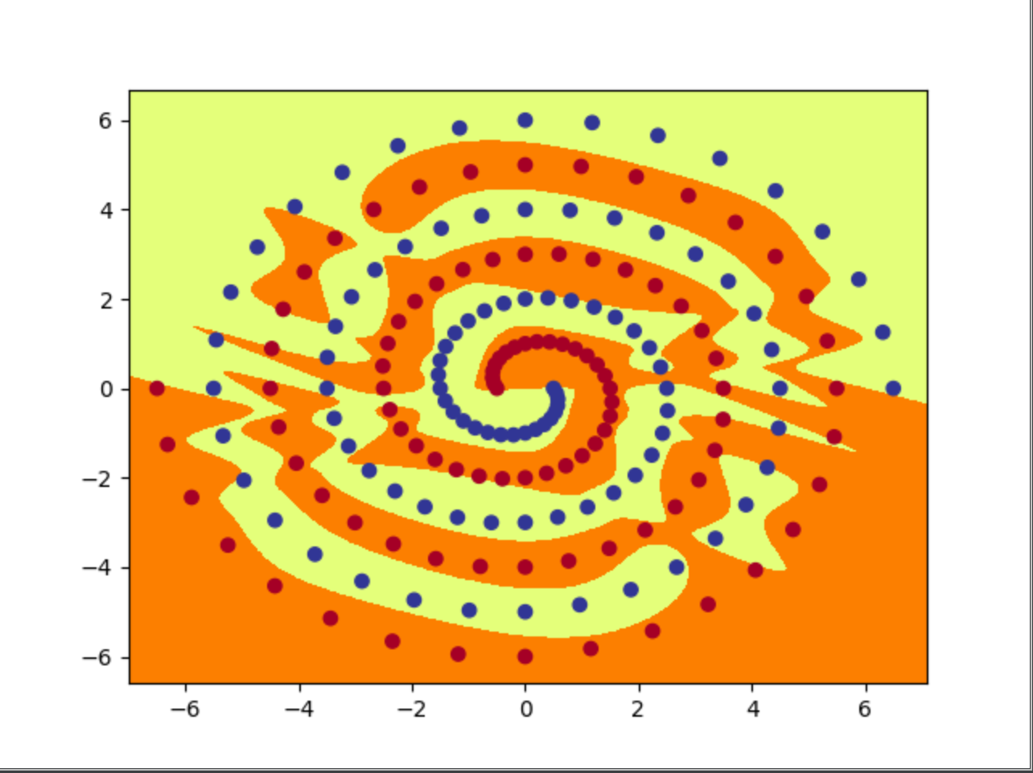

Until now we know that increasing --init value sightly may give us a better performance of accuracy. Finally, we choose 0.15 as our good –init value for our moddel.

5. code is seen in file spiral.py

6.